Indicators
An acid-base indicator is a substance that displays different colours when in the presence of an acid or a base. Like all magic tricks, it has a simple explanation. An indicator is a weak acid that ionizes within a known pH range, usually about 2 pH units. In the equation below the indicator is represented with the generic symbol In. The bronsted-Lowry acid form of the indicator (the protonated form of the indicator molecule) is shown as HIn and the conjugate base of the indicator is shown as In⁻. The following equilibrium exists for the indicator.
HIn_{(aq)} ⇄ H⁺_{(aq)} + In⁻_{(aq)}
Different colours
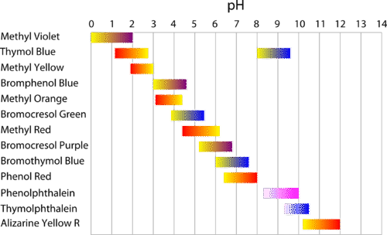
According to LeChâtelier’s principle, the addition of H⁺ ions (as in adding an acid and creating a low pH solution) drives the equilibrium to the left and the protonated HIn predominates. The addition of a base (as in a high pH solution) decreases the H⁺ concentration and drives the equilibrium to the right and the deprotonated In⁻ predominates. Because HIn and IN⁻ are different colours, there is a colour change in the solution when it turns from acidic (high H⁺) to basic (low H⁺). In the case of phenolphthalein, the protonated form is colourless, while the deprotonated form is pink. Figure below shows a variety of acid-base indicators that can be used in titration experiments. Note that each indicator has a pH range in which the colour change occurs.

Indicators are therefore an easy way to observe when a solution turns from acidic to basic, and indicators are used in titrations for the sole reason they are easier to use than pH meters. However because indicators changes colour at different pH ranges, choosing the correct indicator for a titration can be a little tricky.
The decision of which indicator to use depends on where the equivalence point for the titration will be. For example, bromphenol blue has a yellow colour below a pH of about 3 and a blue-violet colour above a pH of about 4. Therefore, Bromphenol blue would not be a good choice as the indicator for a strong acid-strong base titration, which has a pH of 7 at the equivalence point. Instead, it could be used for a strong acid-weak base titration, where the pH at the equivalence point is lower.
Most indicators have two coloured forms, which is useful for titrations. Universal indicator displays the entire rainbow of colours from low pH to high pH. This is another magic trick as Universal indicator is a mixture of different indicators carefully chosen to shown a range of colour changes at different pHs. Universal indicator is used to make pH paper.
Indicators, K_{a} and pH
Consider the indicator equilibrium system
HIn_{(aq)} ⇄ H⁺_{(aq)} + In⁻_{(aq)}
Different colours
Since the pronated form of an indicator has a different colour to its non-pronated form, the exact “middle” point of changing colour can be assumed to be when there is 50% of both forms present. In terms of concentration, this assumption means that the concentration of HIn and In⁻ will be equal at the point at which the indicator is changing colour
If we apply the equilibrium law to this situation then:
$$K_{a}= \frac{\left[H^{+}\right][HIn]}{[{HI}^{-}]}$$
At the middle point of changing colour [In⁻] = [HIn], which means these values cancel out from the equation to give:
$$K_{a}=[H^{+}]$$
And therefore: pKa = pH
The pK_{a} value is simply –log₁₀(K_{a}). Therefore, the consequence of this answer is that the indicator will change colour when the pH is the same value as its pKa value. Hence, as indicators have different equilibriums, and different K_{a} values, they have different pHs at which they change colour. The pH range at which the indicator changes colour can be used to calculate its approximate K_{a}. The opposite is also true though, you can look up an accurate value of K_{a} value for an indicator, apply the –log₁₀ function to get its pK_{a} and therefore know the pH at which that indicator will change colour. In truth the colour change generally occurs over a slightly wider pH range of +/- 1 either side of the calculated pH.

